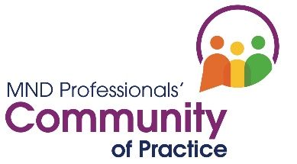
Making a submission
Practice summary/case study

Introduction

A submission is a short document intended to capture peoples’ interest in a project or piece of work. If the submission is accepted the person/author then has the opportunity to present more information about their work.

Within the MND Professionals’ Community of Practice we to want to share examples in which practical problems are explored, or where recommendations and/or theory are put into practice and make a difference. Your submission (practice summary/case study) should engage the reader by telling them what your work or project was about, and why they should get to know more about it. If you are successful you will asked to produce a poster and make a short 10 minute presentation at one of the Community’s Knowledge and Exchange events. You will be supported to do this.

Guidance

Word limit: approx 350
Within this:
- make a statement about the topic you are presenting,
- consider, and state, the value of your learning and to whom it will be of use
- consider if the work relates directly to any recommendation in NICE Guideline NG42 and state clearly which. This is strongly recommended.
- do not include diagrams or references.

Please complete the boxes beneath the headings below. Once completed, please email your form to CoP@mndassociation.org

Your details

Name:
Job title:
Email address:

Title of abstract
This should be no more than 12 words. The title is important. Short attention-catching titles are the most effective. However, it is also important that the title accurately describes the subject you are writing about.

Description (background) 50 words approximately
What happened? What is/was the rationale for the work?
State on which NICE NG42 Guideline recommendation the work was/is based

Aims 75 words approximately
What were your aims? What change was needed? Explain what you did. What steps did you take to put the NICE guideline into practice?

Evaluation (methods) 125 words approximately
What did you do? What steps did you take to put the NICE guideline into practice?
Identify what went well and what could be improved. Explore your thoughts, feelings, and assumptions if relevant.

Conclusion 75 words approximately
What is your key learning? How could your results make a difference to health and social care professionals and/or people living with MND?

Recommendations/Actions 50 words approximately
What will you do in the future? What would you do differently or advise colleagues?

Keywords and key phrases
Provide 5-10 key words which most closely reflect the content of your paper.

