Chiltern Branch Impact Report for 2022
This report summarises the work of the Chiltern Branch of the MND Association for the year ended 31 December 2022. The report includes all financial information – the income generated and how it was spent. We also share some highlights of events held and the work of the Association Visitor team who liaise directly with families living with MND locally. We hope you find it interesting and informative and if you have and questions or feedback, please contact us by email at chiltern@mndassociation.org

INCOME FOR 2022 WAS £24,896
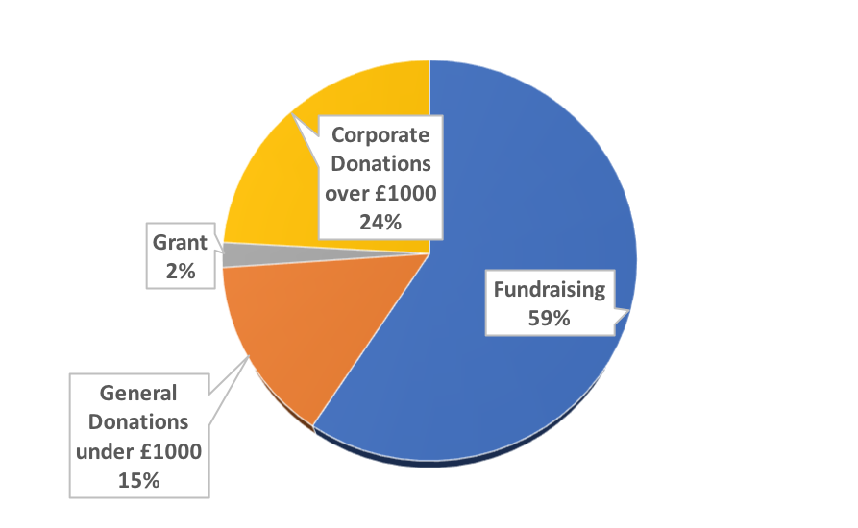
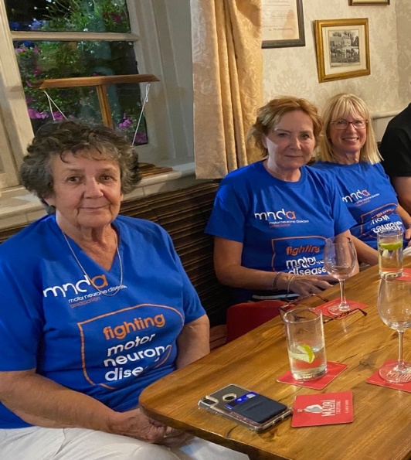
The White Lion in Cryers Hill has continued with their monthly fundraising quiz and other collections raising a further £4,815. The Branch remain very grateful for all they have done and continue to do for the charity

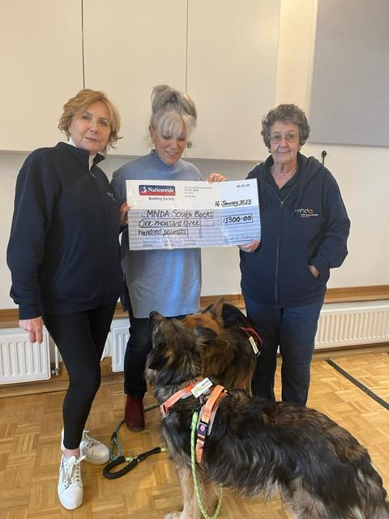
Lizzie Smith organised a quiz in honour of her late husband, John Smith, and raised £1,300 for the Branch. Here she is with the gorgeous Scout and Django presenting the cheque

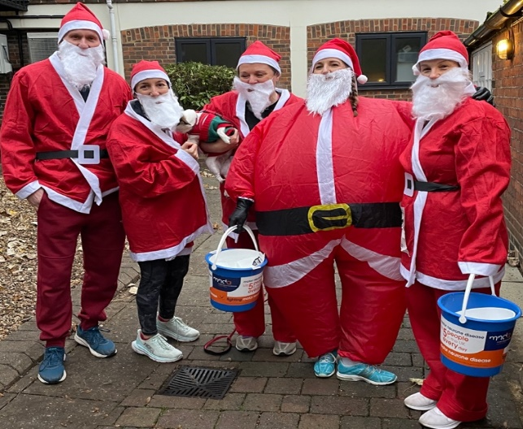
Supporters from The Body Workshop in Marlow braved the cold to join the annual Santa 5k Run organised by Rotary Clubs of Marlow and raised over £1,000

We are very grateful also to
- Vehicle Rental Services, based in Beaconsfield raised £620.79
- The Trinity United Reform Church collected £497.20 in January
- Joanne Simon ran the New York Marathon in October 2022 raising £910
- BBO Big Band who raised £370 from their monthly concert in November
- Finally, our very own entrepreneurial Branch Fundraiser/Visitor, David Alexander, continues his personal fundraising challenge and raised £3,600
Donations and Grants included
- £2,000 from the CF Lunoe Trust in thanks to our Treasurer, John Jeffries
- £3,000 from the Estate of the late Brenda Treacher
- £250 from the Window Film Company, based in Chesham
- £500 from the Roland Callingham Foundation - Bekonscot Model Railway

EXPENDITURE DURING 2022
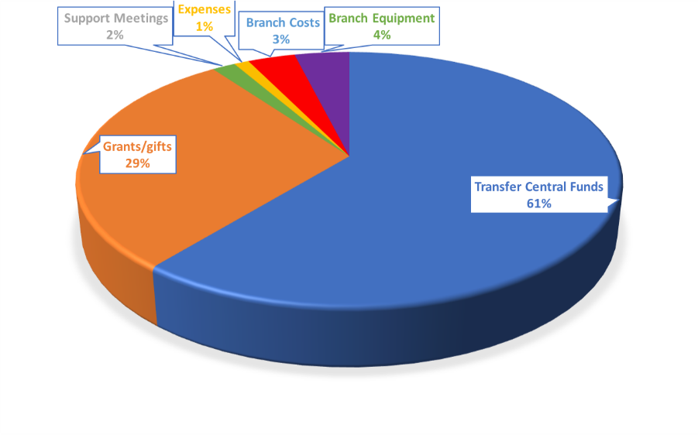
- The Branch awarded a total of £8,113.22 by way of grants to people living with MND in the area made up of 5 Carer’s Grants, 11 Quality of Life Grants and 1 Emergency Grant.
- Additionally, 3 persons living with MND were given Grants from National Office funds to assist with home adaptations and voice banking equipment
- 2 iPads with specialist software purchased for loan to the Speech and Language Therapy Department at Amersham Hospital for use by persons living with MND
- Plants were purchased for all our known carers during National Carers Week in recognition of the huge amount of care and support they provide
- £50 gift vouchers were presented to all those living with MND in December to help with extra costs during the Xmas season
- In accordance with our accounting rules, we transferred £14,000 to National Office to be used towards care and research

Chiltern MND Support Meetings
Finally, after over 2 long years, our monthly meetings at Cedar Barn in Holmer Green were able to safely start again from September 2022. Here, we can meet up again with old friends living with the disease and those newly diagnosed and chat over tea or coffee and cakes. We ended the year with the December meeting which included the ubiquitous Christmas Quiz.

Association Visitors
The AV team comprised four volunteers for most of 2022. Our visitors supported a total of 23 families during the year and made more than 100 visits. Some families prefer a more arm's length approach and visitors adapt to suit the needs of the patient – for example using text and What's App messaging to maintain contact. Our Branch Contact continued to play a key role in welcoming new patients in the area and providing them with support and guidance in the early days after diagnosis. Feedback received from families on the support provided by the AV Team and Branch Contact confirms the value that these roles bring.
As well as practical support which ranges from flagging issues to the relevant Health Care Professional and signposting to MND Association sources of information, the team can apply for a range of Financial Support Grants on behalf of the family. As importantly, families have commented that simply having someone visit and spend time chatting and socialising makes a big difference. These visits are important to both patients and family members who have taken on the caring role.
We remember those who died with MND and the families they have left behind. We remain in contact with many carers and family members and continue to support them after bereavement.
Plans for 2023
The Branch Committee have challenged themselves to raise £30,000 -or more! - during 2023. So far this year we are delighted to report that over £14,000 has been raised.
Future confirmed events to help achieve this challenge for the benefit of those within this area affected by the disease are 2 private garden visits
- Bledlow Manor Gardens on Friday 16th June
- Chenies Manor House Gardens on Wednesday 20th September
Do please come along and join us and invite friends and family!
The Branch Committee and all volunteers remain totally committed to supporting local families impacted by MND in 2023. We have a further two Association Visitors in the pipeline so that we can support more families. We will continue our fundraising efforts for the benefit of those within Chiltern area affected by MND and to continue to raise awareness of this devastating and ultimately fatal disease

