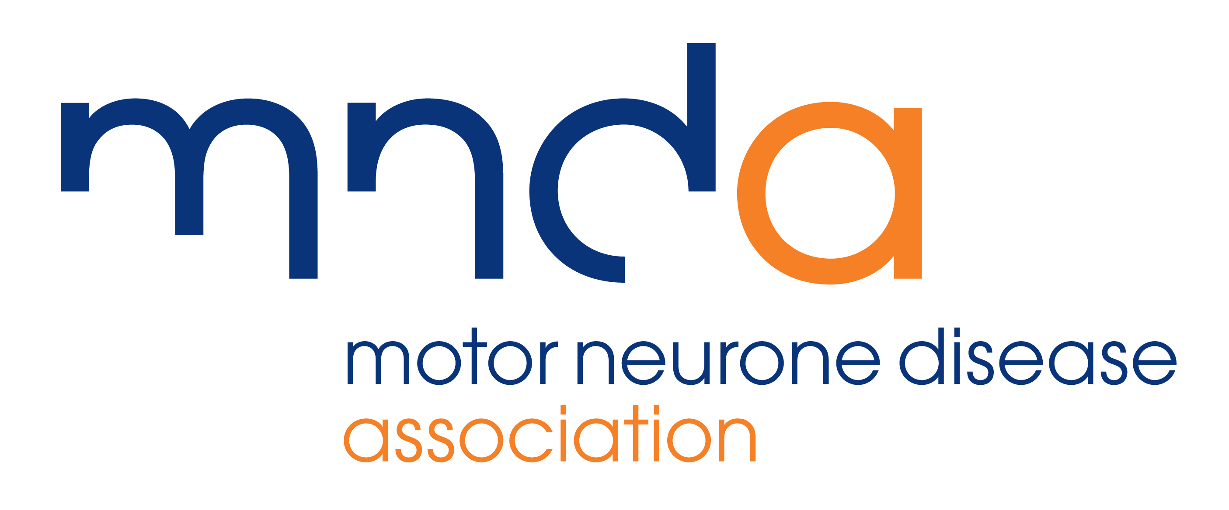

Media release
DATE
Headline
COPY IN HERE

For more information about MND and the MND Association please visit www.mndassociation.org
ENDS

Picture caption: [Who is in the photo ie NAME, has been volunteering for 20 years]

For more information: Please email [YOUR EMAIL ADDRESS] or call [NAME] on [TELEPHONE NUMBER]

About the MND Association:

Please note that style wise motor neurone disease is lower case and then abbreviated to MND. The Motor Neurone Disease Association can be shortened to the MND Association, or the Association but never the MNDA.

The MND Association was founded in 1979 by a group of volunteers with experience of living with or caring for someone with MND. We are the only national charity in England, Wales and Northern Ireland focused on MND care, research and campaigning.

We improve care and support for people with MND, their families and carers.

We fund and promote research that leads to new understanding and treatments, and brings us closer to a cure for MND.

We campaign and raise awareness so the needs of people with MND and everyone who cares for them are recognised and addressed by wider society.

About motor neurone disease (MND):

- MND is a fatal, rapidly progressing disease that affects the brain and spinal cord.
- It attacks the nerves that control movement so muscles no longer work. MND does not usually affect the senses such as sight, sound, feeling etc.
- It can leave people locked in a failing body, unable to move, talk and eventually breathe.
- Over 80% of people with MND will have communication difficulties, including for some, a complete loss of voice.
- It affects people from all communities.
- Around 35% of people with MND experience mild cognitive change, in other words, changes in thinking and behaviour. A further 15% of people show signs of frontotemporal dementia which results in more pronounced behavioural change.
- It kills a third of people within a year and more than half within two years of diagnosis.
- A person’s lifetime risk of developing MND is around 1 in 300.
- Six people per day are diagnosed with MND in the UK.
- It affects up to 5,000 adults in the UK at any one time.
- It kills six people per day in the UK, this is just under 2,200 per year.
- It has no cure.

