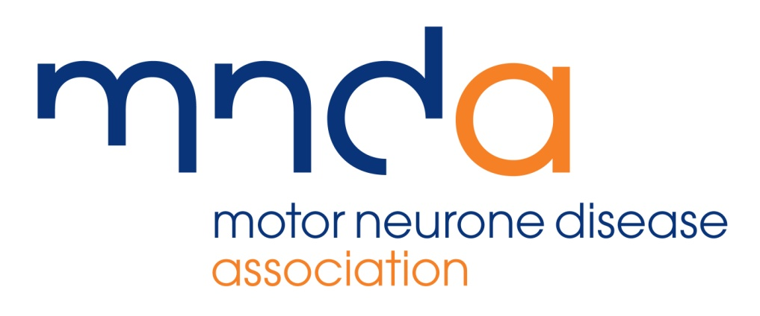
Notice of Photography

Please Note: There will be photography and video at the EVENT NAME. These images will be used for promotional purposes, in future publications and presentations and our digital and social media channels, normally within a five year period from today, DATE.

If you do not wish to appear in any photographs please let a member of the MND Association know and they will make sure that you are not included in any images.

