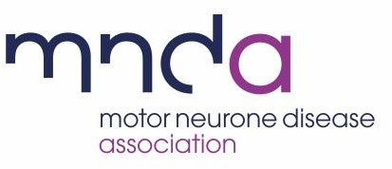

Has the pwMND/pabMND requested this visit? | Yes/No
Have you discussed all the forms of support available including face to face and different forms of remote support and agreed and preferred method for the person you are supporting? | Yes/No
Do you have any relevant health issues which might put you more at risk as regards COVID-19? | Yes*/No | *If yes you may agree to provide support in an alternative way take extra mitigations such as only visiting outside.
Have all those involved with the visit had at least two doses of the COVID-19 vaccine? | Yes/No* | *If no you may agree to provide support in alternative way or take extra mitigations such as only  meeting outside.
Will you (the volunteer) be able to take a rapid lateral flow COVID test within 24 hours of the visit? | Yes/No | *If the result of the test is positive then the visit cannot take place.  The cost of tests can be reimbursed through the expenses process.
Have you discussed and confirmed with the  pwMND/pabMND the safe behaviours that you will follow on the visit?  You should discuss the following arrangements before the visit takes place:  Fresh air – we ask that if possible windows and doors are opened allowing fresh air to circulate. This reduces the risk of transmission  Social distancing - we will be continuing to follow safe behaviours such as keeping a safe distance,  Testing - we will be taking a rapid lateral flow test before visiting  Face coverings - we will wear a face covering during the visit if meeting indoors. Those in the household may also choose to wear a face covering | Yes/No
Is the pwMND using NIV? | Yes*/No. | *If Yes then the person must have taken a lateral flow test with a negative result before the visit can take place. If this is not possible speak to your ASC

